**CE Web Site Album Content Authoring**

In this document, the following fictitious scenario is used as example to illustrate how to create an album in CE site:

*The Results submenu under Scholastic Competition menu will show the 5 competition albums when clicked: Dancing, Kong Fu, Singing, Speech, and Writing.*

The screen shot of this fictitious scenario is shown below.

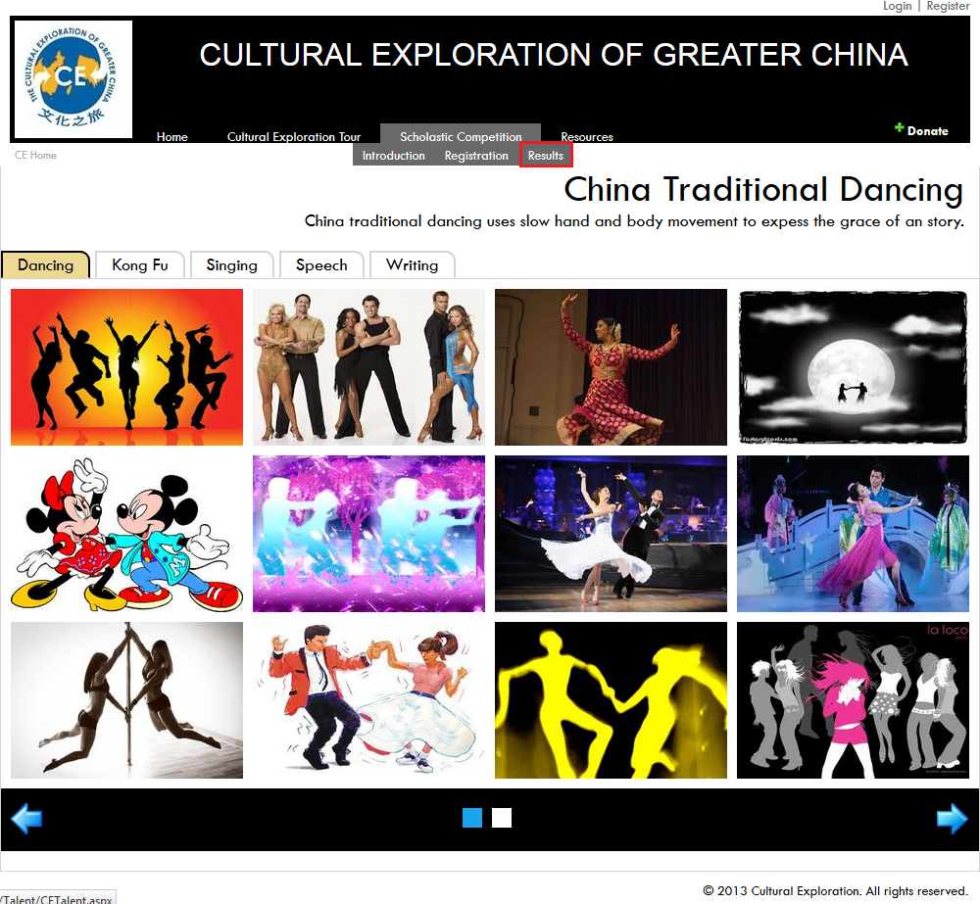

**Step 1: Create the Albums Folder**

There are 5 albums for this scenario: Dancing, Kong Fu, Singing, Speech, and Writing. They are created under the centrally controlled album folder in CE called *Album*.

* Although we can create any folder structure we like, we will keep folder naming convention somewhat parallel with others: the root of the albums will be at */Album/Talent/Competition*.
* Under the root of the albums, create 5 folders, one each for each album:
  + Dancing
  + KongFu
  + Singing
  + Speech
  + Writing

The following screen shot shows the structure:

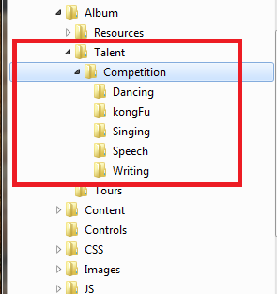

* Copy all photos to each of the folder respectively

The album generator will pick up each photo and display them all. The photo file extensions supported are those popular ones like *jpg, jpeg, png, gif,* and *bmp*.

**Step 2: Create the XML content file for the Albums**

As specified in the html file in **Step 1**, the XML content file URL is */content/talent/results/cealbum.xml*. The following screen shot shows the content of the file.

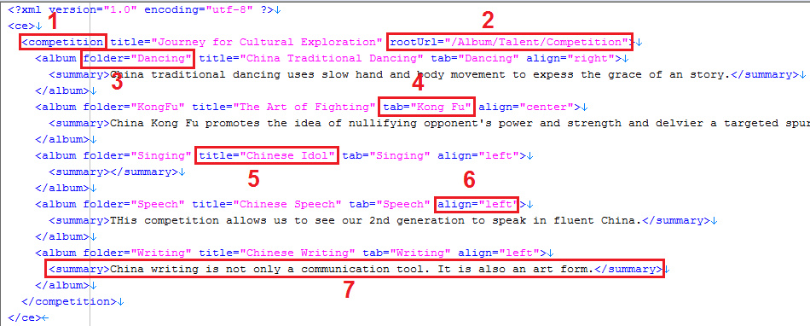

**XML content explanation**

**1** - The name of the albums is *Competition*. This can be any name. If you don’t give a name, ***albums*** is assumed. Note that this name is specified in the html file in **Step 1** so that the album generator can find it.

**2** - The root folder URL of the albums that you created in **Step 2**.

**3** - The album folder name. These are each of the album folders you created in **Step 2**.

**4** - The album name to be displayed on the tab.

**5** - The album title to be displayed on the page.

**6** – The alignment of album title and summary. The value can be *right, left,* and *center*.

**7** - The summary of the album. This is optional.

You can create your album content file from the template file */content/album-template.xml*. You can add up to 10 albums in each of the album content file. **Note**: that you don’t need to add photo file URLs to each album as all photos with the supported image file extensions are automatically picked up by the web site.

**Album page explanation**

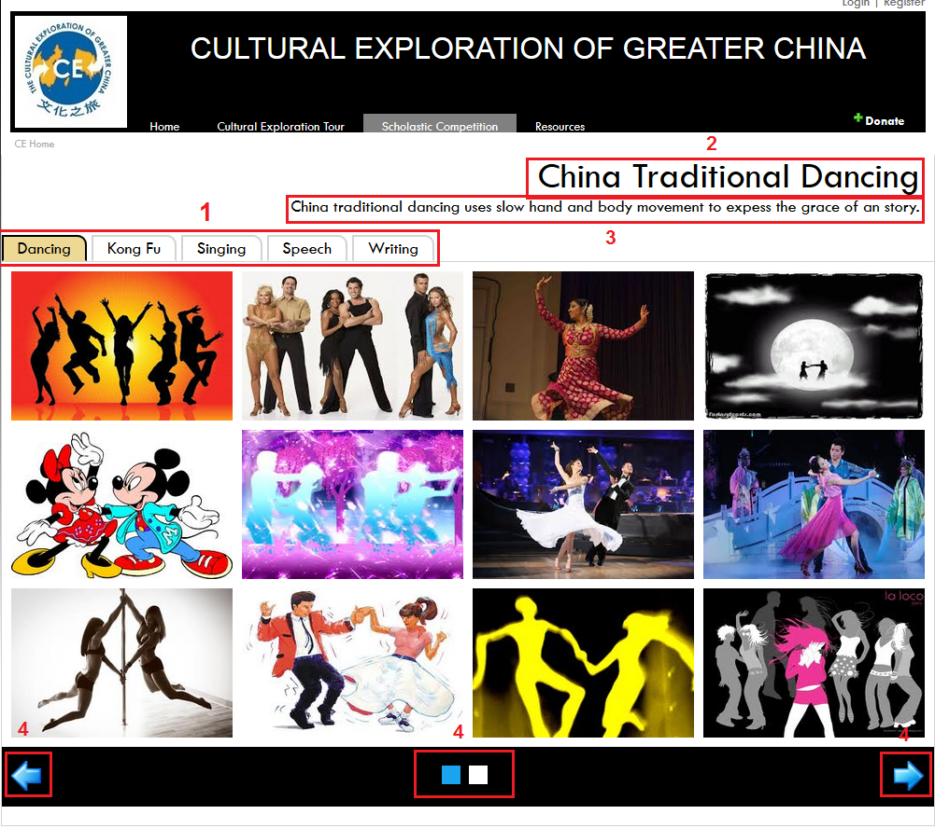

**1** – Each album is displayed in the tab.

**2** - The album page title is right-justified. Other options are left-justified and centered.

**3** - The album summary has the justification as title. The summary is optional.

**4** – Paging button. Alternatively and more easily, the user can use mouse to ‘swipe’ the album pages.

**Step 3: Create HTML Page for the Albums**

There is a page generator tool in CE site to help you create a web page to render your content. Please refer to document *Geneating CE Web Page for Content* for details.

**Step 4: Add content page to CE Site**

* If your content page is to be accessed via menu, you need to edit /content/cemenu.xml to make a link to it.
* If your content page is to be accessed from other page, edit that page to make a link to it.

**Step 5: Test your page**

Test your page to ensure sure it works.

**Album Template File Code List**

<?xml version="1.0" encoding="utf-8" ?>

<ce>

<albums title="..." rootUrl="/Album/...">

<album folder="..." title="..." tab="..." align="right">

<summary>optional; put text here to show when this album is selected</summary>

</album>

<album folder="..." title="..." tab="..." align="left">

<summary></summary>

</album>

<album folder="..." title="..." tab="..." align="middle">

<summary>optional; put text here to show when this album is selected</summary>

</album>

</albums>

</ce>